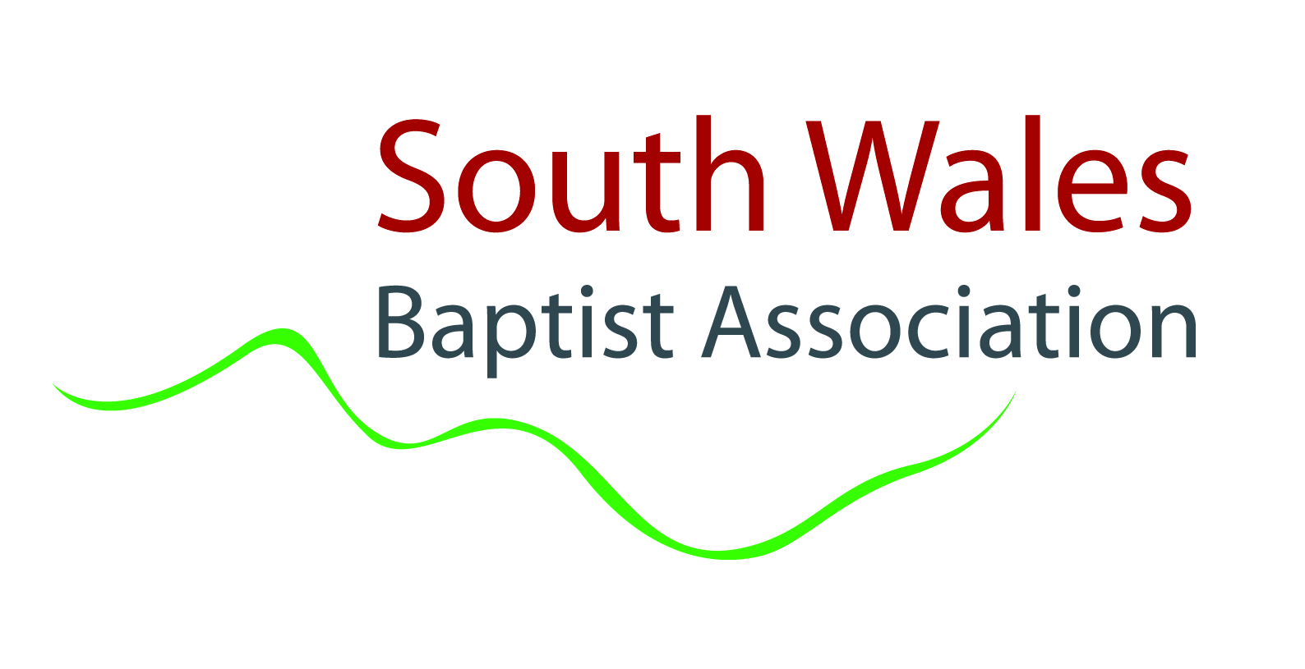

South Wales Baptist Association
Complaints Procedure Form

This form can be used to submit the following complaints:
- Complaints regarding application of procedures or decisions made (please use section A);
- Complaints about the support provided to the church or minister(s)/church workers by the South Wales Baptist Association (SWBA) (please use section B);
- Complaints regarding SWBA staff conduct (please use section C).

Please note this form is not for complaints of the following nature:
- Complaints regarding the performance of an accredited Minister or Church Worker (this is an issue to be dealt with by individual churches or organisations);
- Complaints regarding the conduct of an accredited Minister or Church Worker where there is no suggestion that their conduct is either unbecoming or amounts to serious misconduct (this is an issue to be dealt with by individual churches or organisations);
- Complaints about the application of the SWBA’s procedures or decisions made by the SWBA which do not directly relate to the complainant;
- Grievances relating to employment decisions (this is a matter for the ‘employer’s’ grievance procedure).

SECTION A – Complaints regarding application of procedures or decisions made
Please provide the following information:
Your name:
Your address:
Your telephone numbers:
Your email address:

The actions you are complaining about:

When they took place:

Why you think the actions are wrong:

Details of what you have done to try and resolve your concerns:

What you consider would resolve your concerns:

Details of who else you have reported the matter to:

Any additional information:

Confirmation that you are happy for detail of your complaint and the supporting documentation to be provided to those who have made the decisions in question:

Please note your complaints will not be dealt with unless you provide all of the information set out above.
Please send this form to the Regional Minister, Team Leader (mark@swba.org.uk) at the following address marked ‘Private and Confidential’, who will arrange for an investigation to take place. Where your complaint relates to actions of the Regional Minister, Team Leader, please send this form to the Moderator of the Trustee Board (moderator@swba.org.uk) at the same address who will arrange for an investigation to take place:
SWBA, 54 Richmond Road, Roath, Cardiff, CF24 3UR
SECTION B- Complaints about the support provided to the church or minister(s)/church workers by the South Wales Baptist Association.
Please provide the following information:
Your name:
Your address:
Your telephone numbers:
Your email address:

Name of person or church you consider did not get appropriate support:

Details of when your complaint refers to:

Details of the situation(s) to which your complaint refers:

Details of any witnesses to the issues of concern:

Details of what you have done to try and resolve your concerns:

What you consider would resolve your concerns:

Any additional information:

Confirmation that you are happy for detail of your complaint and the supporting documentation to be provided to the person complained about should it be necessary to do so.

Please note your complaints will not be dealt with unless you provide all of the information set out above.
Please send this form to the SWBA Regional Minister, Team Leader (mark@swba.org.uk) or to the Moderator (moderator@swba.org.uk), at the following address marked ‘Private and Confidential’, who will arrange for an investigation to take place:
SWBA, 54 Richmond Road, Roath, Cardiff, CF24 3UR

SECTION C – Complaints regarding staff conduct
Please provide the following information:
Your name:
Your address:
Your telephone numbers:
Your email address:

The name of the person you are complaining about:

The events you are complaining about:

Details of when the events took place:

Details of where the events took place:

Details of any witnesses to the issues of concern:

Details of what you have done to try and resolve your concerns:

What you consider would resolve your concerns:

Details of who else you have reported the matter to:

Any additional information:

Confirmation that you are happy for detail of your complaint and the supporting documentation to be provided to the person complained about should it be necessary to do so:

Please note your complaints will not be dealt with unless you provide all of the information set out above.
Please send this form to the Regional Minister, Team Leader (mark@swba.org.uk) at the following address marked ‘Private and Confidential’ who will arrange for an investigation to take place. Where your complaint relates to actions of the Regional Minister, Team Leader, please send this form to the Moderator of the Trustee Board (moderator@swba.org.uk) at the same address who will arrange for an investigation to take place:
SWBA, 54 Richmond Road, Roath, Cardiff, CF24 3UR

