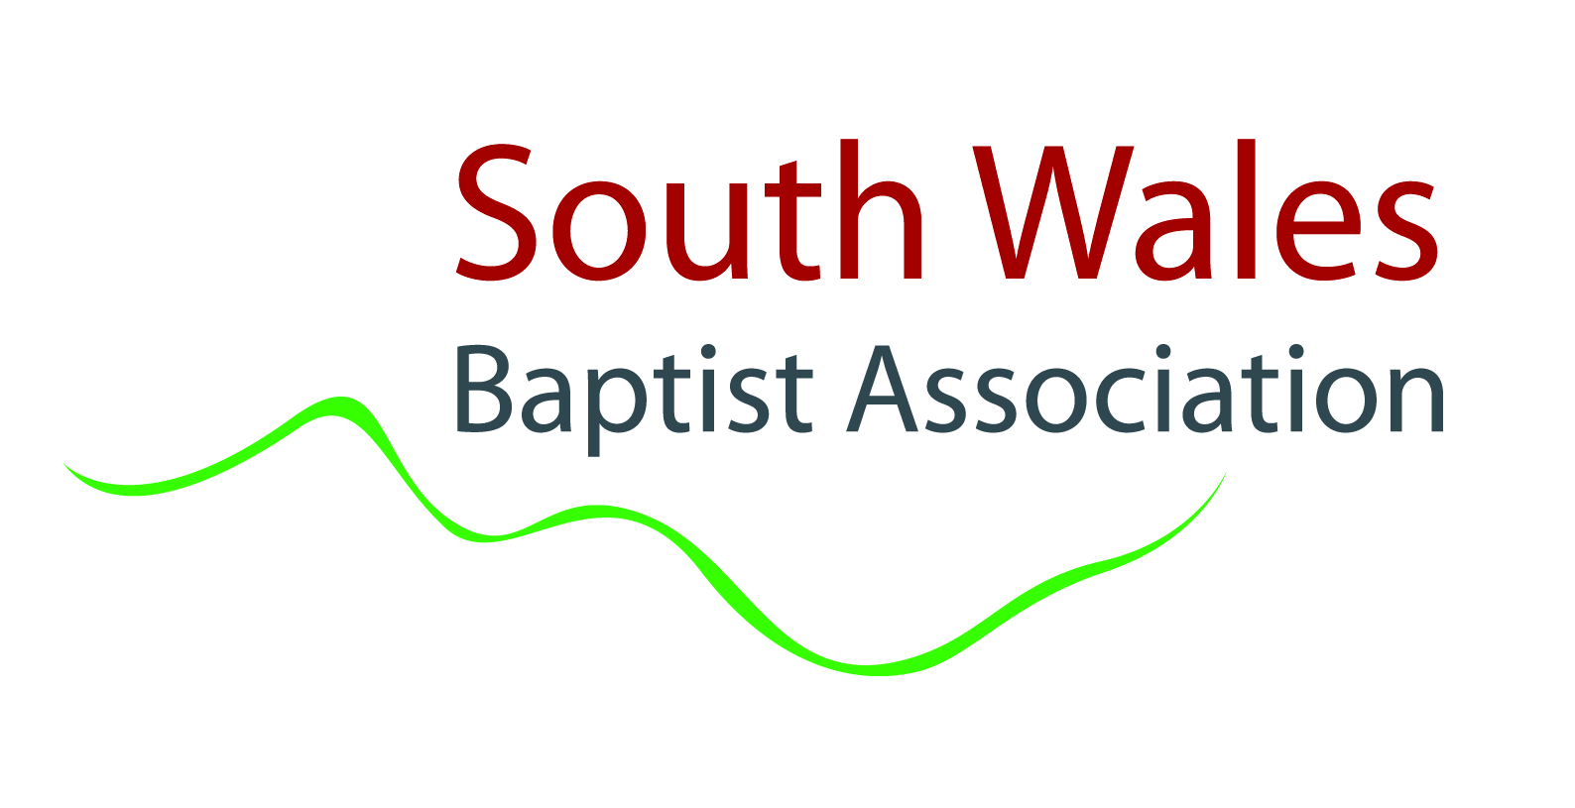

South Wales Baptist Association
Complaints procedure
- Preamble
- The purpose of the South Wales Baptist Association (SWBA) Complaints Procedure is to provide a clear process for dealing with complaints relating to decisions taken by its staff, trustees or committees, including those who are appointed on a voluntary basis to serve on working groups or committees.
- Any complaints about accredited Ministers or Church Workers are handled through The Baptist Union of Great Britain (BUGB) Ministerial Recognition processes, which are available on the BUGB website.
- We must be mindful that people make mistakes and so making a formal complaint should be a last resort. SWBA’s desire is that wherever there are concerns relating to actions taken by SWBA those with concerns will do all they can to resolve those concerns informally rather than escalating them into a formal complaint. It is advisable to follow Scriptural principles of reconciling differences wherever possible before resorting to this formal process.
- However, we recognise that in some cases there will be no alternative but to resort to a formal complaint. This formal procedure should only be instigated when attempts to resolve the issue informally have failed or where, due to the nature of the complaints, it is not appropriate to address it with the person(s) about whom the complaint is made.

- Who is able to instigate a complaint?
Any person can bring a complaint against SWBA. If SWBA receives a number of inter-related complaints or a number of people make the same complaint SWBA may decide to consolidate the investigation into the complaints or to deal with the earliest complaint first. The approach will depend on the nature of the complaints and the timing of the receipt of the complaints.

- The types of complaint which will be considered
- The application of the SWBA’s procedures or decisions made by SWBA which directly relate to the complainant (unrelated to the conduct of an Accredited Baptist Minister or Church Worker).
- The conduct of staff employed by the SWBA (unless the complaint relates to employment with SWBA).
- The conduct of trustees and others who are appointed to serve on a voluntary basis on boards, committees and working groups of SWBA.
- Complaints about the support provided to a church or minister(s)/church workers by SWBA.
- Complaints about the conduct, performance or behaviour of an accredited Minister or Church Worker which either cannot or are not being dealt with by the individual church concerned. Serious complaints are dealt with through the BUGB Ministerial Recognition process.

- The types of complaint which will not be considered
    - Complaints about the application of SWBA’s procedures or decisions made by SWBA which do not directly relate to the complainant.
    - Grievances relating to employment decisions (this is a matter for the “employer’s” grievance procedure).
Complaints raised which do not comply with the requirements of this procedure will not be dealt with and the complainant will be sent a copy of the complaints procedure.

- How to make a complaint
A Complaints about the application of procedures or decisions made
A complaint must be made in writing, which includes email, and must set out the following:
- The actions you are complaining about;
- When they took place;
- Why you think the actions are wrong;
- Details of what you have done to try and resolve your concerns;
- What you consider would resolve your concerns;
- Details of who else you have reported the matter to;
- Any additional information;
- Confirmation that you are happy for detail of your complaint and the supporting documentation to be provided to those who have made the decisions in question.

Any supporting documentation that exists should be enclosed with your letter of complaint.
Your complaint will not be dealt with unless you provide all of the information set out above. SWBA has a form that can be used to make a formal complaint which can be requested from the Association office.
The complaint should be sent to the Regional Minister Team Leader (Rev Mark Fairweather-Tall, SWBA, 54 Richmond Road, Cardiff CF24 3UR or email mark@swba.org.uk) who will arrange for an investigation to take place. Where your complaint relates to actions of the Regional Minister Team Leader, it should be sent to the Moderator of the Trustee Board who will arrange for an investigation to take place.
Whilst complaints are to be lodged in writing, it would be usual for a face-to-face meeting to also take place between the Regional Minister Team Leader and/or the Moderator and the complainant.

B Complaints regarding SWBA staff, trustees and other volunteers serving on SWBA committees and working groups
A complaint must be made in writing, which includes email, and must set out the following:
- The name of the person you are complaining about;
- The events you are complaining about;

- Details of when the events took place;

- Details of where the events took place;
- Details of any witnesses to the issues of concern;
- Details of what you have done to try and resolve your concerns;
- What you consider would resolve your concerns;
- Details of who else you have reported the matter to;
- Any additional information; and
- Confirmation that you are happy for detail of your complaint and the supporting documentation to be provided to the person complained about should it be necessary to do so.
Any supporting documentation that exists should also be enclosed.
Your complaint will not be dealt with unless you provide all of the information set out above. SWBA has a form that can be used to make a formal complaint which can be requested from the Association office.
The complaint should be sent to the Regional Minister Team Leader (Rev Mark Fairweather-Tall, SWBA, 54 Richmond Road, Cardiff CF24 3UR or email mark@swba.org.uk)who will arrange for an investigation to take place. Where your complaint relates to actions of the Regional Minister Team Leader, it should be sent to the Moderator of the Trustee Board (Rev Dr Graham Watts, SWBA, 54 Richmond Road, Cardiff CF24 3UR or email moderator@swba.org.uk) who will arrange for an investigation to take place.

- How the complaint will be dealt with
- In the first instance, the complaint will be acknowledged in writing or by email within five working days.
- The Regional Minister Team Leader (or the Moderator of the Trustee Board where the complaint relates to the Regional Minister Team Leader) will appoint an investigator(s) to look into your complaint. You will be told who will be appointed to investigate.
- The complaint will then be reviewed by the investigator(s). The person(s) investigating will seek to:
    - Establish what has happened and when it happened and who else was involved;
    - Meet with the complainant or contact them if there is a need for clarification regarding the complaint or further information is required;
    - If following the initial information and any discussions with the Complainant the investigation is to proceed the investigator(s) will inform those who have been complained about of the nature of the allegations made (unless in the opinion of the investigator(s) this would prejudice the investigation interview);
    - Interview those involved and those complained about where necessary to understand their account of events;
    - Keep notes of all investigatory interviews.

  - Complaints regarding application of procedures or decisions made
Once the investigation is concluded the investigator(s) will decide whether the complaint is well founded and send the complainant their decision. Where any aspect of the complaint(s) is upheld the investigator(s) should also specify the actions suggested in order to remedy the situation.

b. Complaints regarding SWBA staff conduct
    - If the person investigating concludes that the evidence suggests that conduct worthy of disciplinary action may have taken place, the issue will be dealt with under the Staff Disciplinary Processes.
    - Where the person complained about is an accredited person they may also be dealt with under the recognition rules if the investigator(s) concludes that the evidence suggests that conduct unbecoming or serious misconduct may have taken place. If this is the case, the matter will be dealt with under the BUGB Ministerial Recognition rules from this point onwards.
iii. The complainant will be informed that the matter is being dealt with in this way, and will be given details of the BUGB Ministerial Recognition rules.

c. Complaints regarding SWBA trustees and others who are appointed to serve in a voluntary basis on a board, committee or working group of SWBA
    - If the person investigating concludes that the evidence suggests that misconduct may have taken place, the issue will be referred to the Moderator of the SWBA Trustees Board who will chair a panel of three trustees unconnected with the matter under investigation to consider the evidence and to come to a decision. The panel may choose to invite the complainant or the person(s) complained about to address the panel, but are not required to do so. Such a decision will be communicated to the complainant and to the individual(s) complained about within five days of the panel’s decision. The Moderator will also inform the Charities Commission if the circumstances require this to be done.
    - Where the person complained about is an accredited person they may also be dealt with under the recognition rules if the investigator(s) concludes that the evidence suggests that conduct unbecoming or serious misconduct may have taken place. If this is the case, the matter will be dealt with under the BUGB Ministerial Recognition rules from this point onwards.
    - The complainant will be informed that the matter is being dealt with in this way, and will be given details of the BUGB Ministerial Recognition rules.

- Timescales
- Following receipt of each complaint the investigator(s) will within 21 days give the complainant an estimate of their expected timescale for dealing with the complaint.
- In the case where, as the investigation proceeds, it is not possible to meet those timescales, an updated timeline for dealing with the complaint will be provided.
- The more complex the complaint the longer the timescale is likely to be. In some cases it can take several months to properly investigate and respond to a complaint.
- If the subject matter of the complaint has also been referred to the Police it may be that SWBA’s investigation into the complaint cannot commence or be completed until the Police have completed their investigations and either decided not to proceed or a Court decision has been taken. Our approach in these cases will depend on the particular circumstances of the case.

- Child or Adult at Risk Protection issues
Where a complaint relates to child or adult protection issues the investigation and follow up actions will be carried out in accordance with SWBA’s child or adult Safeguarding procedures in place and these may be adjusted to account for the particular circumstances and any guidance issued by the local authority designated officer involved in the case.

- If the complainant is unhappy with the outcome of the investigation
  - Complaints regarding application of procedures or decisions made
Complainants have the right to appeal any decision on a complaint on these issues. Written notice of intention to appeal should be made within 14 days of the date the outcome of the complaint was sent to the complainant. The appeal itself should be made within a further 14 days. The appeal should be in writing, which includes email, and must be sent to the Moderator (Rev Dr Graham Watts, SWBA, 54 Richmond Road, Cardiff CF24 3UR or email moderator@swba.org.uk) who will arrange for the appeal to be considered by someone other than the person who took the initial decision.

The appeal must set out:

    - The grounds on which the complainant is appealing; and
    - What the complainant considers would resolve their concerns.
  - Complaints regarding the conduct of SWBA staff, trustees and those in voluntary appointments
- There is no right for complainants to appeal against the outcome of the investigations into SWBA staff, trustee and volunteer conduct. This is because SWBA believes that individuals in these groups who are under investigation need certainty that if an investigation has concluded it will conclude the matter.
- If new evidence comes to light that has not previously been submitted that should be provided to the investigator(s) who will determine whether further investigation is necessary in light of that new evidence.

- Vexatious complaints
If the investigator(s) concludes that a complaint has been made vexatiously or in bad faith SWBA reserves the right to take the following actions:
    - In all cases to inform the complainant that this is how the complaints are being seen, the reasons why, and the consequences of this;
    - In the case of Baptist Church members who have made complaints: to write to the Deacons of the Church indicating that the particular church member has been found to have made a vexatious complaint or has made a complaint in bad faith and that they may wish to consider exercising church discipline in relation to that;
    - In the case of a minister who has made a complaint: this would be treated as an issue of potential conduct unbecoming and would be dealt with under the Baptist Union of Great Britain’s Ministerial Recognition Rules.
    - In the case of complaints from anyone else: further complaints and correspondence from the complainants would be ignored.

- Contact by the complainant and person complained about
Once a formal complaint has been made, the complainant should avoid any ongoing discussion or correspondence with the person complained about relating to the complaints without the consent of the investigator(s). Similarly, the person complained about should avoid discussion with the complainant relating to the complaint, without the consent of the investigator(s).

- Confidentiality
The fact of and content of the complaint will be kept confidential save in so far as is necessary in order for SWBA to properly investigate the complaint and reach a decision relating to it unless SWBA personnel are aware that the complainant has not treated the fact or content of their complaints as confidential.
SWBA expects complainants to maintain reasonable confidentiality as to the nature and content of their complaint so that the investigator is able to work without obstruction.

